Shabbos Stories For
Parshas chaye sarah 5787
Volume 18, Issue 8 27 Cheshvan/November 7, 2026
Printed L’illuy nishmas Nechama bas R’ Noach, a”h
For a free email subscription, send your request to keren18@juno.com
Nine Years
By Rabbi Moshe Hirschberg

Reb Avraham Yehoshua Mendlowitz, from Kiryas Yoel, lived a tragically short life. Yet in the years he was given, he accomplished an extraordinary amount. He supported numerous tzedakah causes and was always looking for opportunities to help another Jew.
One day, Reb Avraham Yehoshua was standing in a crowded pharmacy. Ahead of him in line was Reb Chaim Yosef Gottlieb, an older man who had come to pick up a medication he needed.



When Reb Gottlieb reached the counter, the pharmacist gave him some unwelcome news. “Your insurance won’t cover this medication.”
“How much does it cost?” he asked.
The answer was staggering: several thousand dollars. And this was not a one-time prescription. He would need the medication every month.
Reb Gottlieb realized that he could not afford it. He turned away from the counter, prepared to leave without the medication.
Reb Avraham Yehoshua had overheard the exchange. After Reb Gottlieb walked away, Reb Avraham Yehoshua approached the counter. “How much is the medication?”
“A few thousand dollars.”
“Put it on my credit card.”
The pharmacist looked at him to make certain he understood. “You realize this isn’t just for today. He needs this medication every month, and it will cost several thousand dollars each time.”
Reb Avraham Yehoshua barely paused. “Then charge my credit card every month.”
A Jew needed medication, and Reb Avraham Yehoshua had found a way to provide it. The matter was settled.
Two weeks later, as Reb Avraham Yehoshua was responding to a Hatzalah call, he suffered a massive heart attack. It was extremely serious. Yet, b’chasdei Hashem, paramedics was nearby, and his life was saved. Against the odds, Reb Avraham Yehoshua survived.
Life continued. So did the monthly charges. Month after month, year after year, Reb Avraham Yehoshua paid for Reb Gottlieb’s medication. Several thousand dollars at a time went onto his credit card, without Reb Avraham Yehoshua seeking recognition for what he was doing.
Nine years passed. On the Shabbos before Selichos, 5787, Reb Gottlieb passed away. His medication was no longer needed.
Just a few hours later, the first night of Selichos, Reb Avraham Yehoshua Mendlowitz suddenly collapsed. He, too, passed away.
Only then did the remarkable sequence of events come into sharp focus. Two weeks after Reb Avraham Yehoshua had undertaken to pay for another Jew’s life-sustaining medication, he had suffered a heart attack that could have ended his own life. Instead, he was granted another nine years.
For those same nine years, he silently paid for Reb Gottlieb’s medication. And when Reb Gottlieb no longer needed the medication, Reb Avraham Yehoshua’s additional years came to an end as well.
We cannot know the calculations of Shamayim. But the timing has a remarkable message: For nine years, Reb Avraham Yehoshua quietly helped sustain the life of another Jew.
And for nine years, his own life was sustained.
Nine years of tzedakah.
Nine years of life.

Reprinted from the Parshat Lech Lecha 5787 email of Zichru Toras Moshe.

To Beard or Not To Beard
Rabbi Moishe Yosef Engel

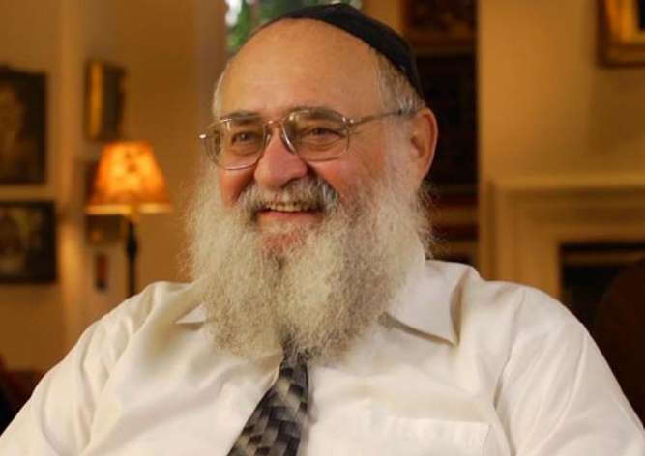

I was born with a hole in my heart — otherwise known as an atrial septal defect — where a fissure exists in the wall separating the heart’s two upper chambers. This defect was discovered when I was two years old, but it was not life-threatening and the complicated surgery — which would be necessary in the future — could wait until I was a teenager.
The time finally came when I was seventeen. Back then, an operation to repair a hole in the heart was much more rare-and-risky than it is today and, certainly, “open heart surgery” was very scary to me as a teenage boy. As it turned out, the [Lubavitcher] Rebbe had a great deal to do with putting me at ease.
By way of background, I was raised in a traditional, though not completely Torah-observant, home. Nonetheless, my widowed mother wanted me to get a religious Jewish education, so she sent me to a local Jewish cheder in Montreal where we lived. One day, however, I came home crying because the teacher slapped me for forgetting my tzitzit, so she pulled me out. Fortunately, an uncle persuaded her not to send me to public school, but to the nearby Lubavitcher yeshivah which had a gentler approach to educating little boys.
The yeshivah made an annual trip to New York to meet the Rebbe, and that is how I first met him when I was twelve years old, and then at least once every year thereafter.
All along, I had been getting regular check-ups and my heart condition was stable, but I knew that the operation was necessary and would come soon. My mother took out special insurance for this purpose, and it was decided that I would have the operation right after the insurance kicked in and started providing coverage, which was March 1, 1964.
About a month before this, I went for my annual visit to see the [Rebbe and I asked for his blessing. I explained my situation and showed him slides of my heart. At around that time, a new procedure had been introduced, as I explained that to the Rebbe. I also mentioned that I had been told that only about a hundred operations like this had been performed so far in Canada.
In response, the Rebbe recommended that I get a second opinion from a specialist in this field and said that the local Chabad doctor and his personal physician, Dr. Avrohom Seligson, would find the right cardiologist for me to see. Dr. Seligson set up the appointment right away, but after he already did so, I had to tell him that my mother was a poor widow and there was no way I could ask her to pay hundreds of dollars for something like this. “Don’t worry,” he said simply, “the Rebbe has already taken care of the payment.”
So, I went to the specialist who confirmed that the operation was needed and reassured me that it would be okay.
Now, when the Rebbe told me to get a second opinion, the operation was already scheduled for a few days after Purim. The Rebbe remarked that this was close to Passover, and I immediately replied that I was certainly happy to postpone it till after.
“Why push it off that far?” the Rebbe asked. “Adar [the month of Purim] is a month of mazal!”
Then the Rebbe gave me a blessing that the operation would be successful and, as a result, instead of being petrified, I went into the hospital with a whole different attitude.
That was not the only time that the Rebbe was instrumental in changing my attitude.
After a number of years in the Lubavitcher yeshivah, I had resolved to become a fully-committed chasid, which in my young mind meant growing a beard and wearing my tzitzit outside my pants so they could be readily seen.
Now, I should mention that both my mother and father were Holocaust survivors — in fact, I had been born in a displaced persons camp in Germany. Once we immigrated to Canada, my parents were concerned that I properly adjust to life in the new country, speak good English, and so forth. After my father passed away when I was ten, my mother was all the more determined that I should be a success in America. Even though she did want me to have a Torah education, going around dressed like a Jew from the Old Country was a step too far for her, and it really disturbed her.
Whenever I was home, she would be nagging at me to tuck the tzitzit inside my pants out of view. And when my beard started growing out, she would be nagging me to shave it off. “Why?” I’d retort, “I am proud to be a Jew!” To which she’d respond, “We don’t do that here!”
We’d get into shouting matches whenever the subject came up, which — at a certain point — was almost every night at dinner.
Afterwards, I’d always feel terrible because I was supposed to be following the Torah commandment to respect my mother. Not only that, she was a widow, and there are many Torah prohibitions against hurting a widow. And I was bringing her to tears.
I very much wanted to be a good Lubavitcher chasid with a beard and tzitzit out, but I also didn’t want to hurt my mother, so I didn’t know what to do.
In the end, I laid out my dilemma in a letter to the Rebbe — asking for his advice and his blessing — and I brought this letter with me to the next audience.
When the Rebbe read what I wrote, he said (and I am paraphrasing because I don’t remember the exact words): “Concerning the issue that you have with your mother, I suggest that the next time she brings up this subject you don’t argue with her, don’t answer back, just let her say what she feels she needs to say. Just listen to her and sit there respectfully.”
I took his advice to heart.
The next time my mother asked at dinner, “Nu, when are you cutting off that beard already?” I just sat there. “Moishele, when?! Come on, you want me to cut off your beard in the middle of the night? You know it bothers me!”
I just sat there. Didn’t say anything, didn’t fight back, and dinner continued. The next night, the same question, the same response from me. And that was it — the issue never came up again.
In retrospect, I realized that the solution was simple — the problem went away when I stopped adding fuel to the fire. As for her part, I think my mother realized that I was going to follow my own path, but that I didn’t want to fight about it, and so she let it go.
In the end, my mother herself became much more religious, and she was very proud of her son being a Lubavitcher chasid and, eventually, an emissary of the Rebbe.

Reprinted from the Parshat Noach 5787 email of “Here’s My Story [with the Lubavitcher Rebbe, zt”l’], a project of the JEM Foundation. Since 1970, Rabbi Moishe Yosef Engel has served as a Chabad emissary in Long Beach, California. He was interviewed in September 2011.
For all Flesh had Corrupted Its Way Upon the Earth.

The Baal Shem Tov, zt”l, once davened Mincha in the forest with great fervor. An astonishing scene occurred: all the animals stood on their hind legs and seemed to join in prayer to Hashem.
The Baal Shem Tov explained this through the verse when a person prays to Hashem, it inspires all creation to praise Him as well. He connected this to even the animals were affected by the corruption of man. When people are corrupt, the world around them is also negatively influenced.
Similarly, when people serve Hashem with Torah and tefillah, they elevate all of creation, bringing blessing and goodness to the world.

Reprinted from the Parshas Noach 5787 email of The World of Belz Weekly email.

Let There Be Light
Rabbi Yechiel Spero

As Refael and Chani Mendlowitz were flying over Connecticut on their return trip from Eress Yisrael, they sensed that something was terribly wrong. The stewardesses were whispering and running to the front of the cabin. What the passengers didn’t know was that most of the Northeastern United States was in the same panic; a huge blackout had struck many states, and most citizens were sure that this was another terrorist attack.
The passengers’ frantic attempts to contact relatives proved futile as cell phones were rendered utterly useless. The initial fear lasted only a short while, until they received word of what had happened and were assured that most likely terrorism was not involved. The more immediate problem was landing the plane without any guidance from on-ground lighting.
At first, airport traffic control intended to divert their El Al flight to Washington D.C., and while that was certainly closer to where the Mendlowitzes lived – Silver Spring – it did not help them because their car was in New York at a relative’s home, awaiting their return. In the end, the passengers were told that theirs would be the last plane allowed to land at Kennedy Airport.
Once they landed, they were informed that airport security would not allow them to disembark for at least an hour. Hot, anxious, and very thirsty, they were finally released into a darkened airport, where finding their luggage was quite an adventure. Tired and exhausted, they finally exited the terminal and attempted to get a cab. And then the full impact of what had happened hit them. It was an eerie, discomforting sight: All of New York was pitch black. No street lights. No building lights. Nothing!

The taxi line stretched for blocks, and since all traffic in the area was slowed due to the lack of traffic lights, they realized that they would be waiting for a cab for hours. While they were pondering their next move, a shuttle bus pulled up, offering to take them where they needed to go for $18, a bargain compared to the $100 the taxis had been charging.

They were completely exhausted as they settled in for the short drive. When they reached their relative’s home, they paid the kind driver and thanked him for his assistance. But when Refael tried the key he realized it did not fit; either he had been given the wrong key or had misplaced the right one. Now what would they do? It was midnight of this never-ending day, and they were at their wits’ end. It was then that they noticed a car parked down the street with people in it. Maybe these people live on this street and will let me in so that I can make a few phone calls, he thought.

Refael cautiously approached the car. The sight that he beheld brought tears to his eyes. Inside were two men – a father and his son – learning together. They had a set time for their learning, and were determined not to let the blackout change their plans. They had decided that learning in a car, however dimly lit it was, was better than canceling. As for Refael, these men were a sight for sore eyes; and of course, they were more than happy to help the desperate couple.

For a long time afterwards Refael could not get the sight of this father and son out of his mind. Imagine, he thought to himself, in a world of utter darkness, a tiny light shines through like a beacon – the light of Torah.

“Ki ner misvah veTorah ohr – A misvah is a candle, and Torah is light.”(Touched by a Story 3)

Reprinted from the Parashat Noach 5787 email of Rabbi David Bibi’s Shabbat Shalom from Cyberspace.

Rav Chaim’s Advice
By Yoni Schwartz

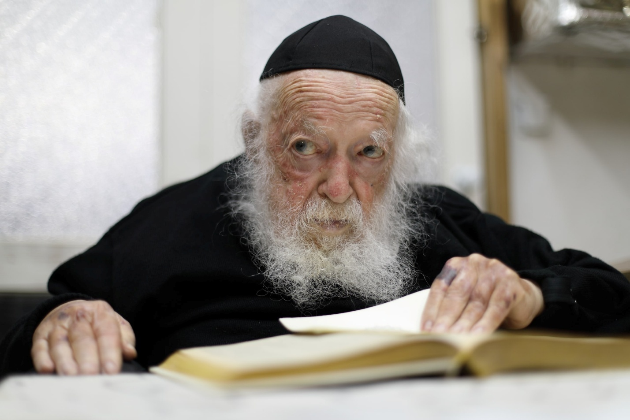
Rav Chaim Kanievsky

There was a certain man in Eretz Yisrael who lived in a peaceful area in a quiet apartment building. One day, as he entered the lobby, he saw furniture, beds, sofas, loveseats, recliners, and every kind of furniture imaginable filling the entire space. He had to weave between the various pieces of furniture just to squeeze through and get where he needed to go.
One of the residents had decided to open a furniture business in the lobby without consulting anyone else because renting a store was too expensive. The man went to Rav Chaim Kanievsky, ZT”L, and said, "This is eating me alive. I have to squeeze between beds, weave my way through furniture, and hear the commotion of customers when I just want to relax. I want to live a normal life. I want a normal lobby! What this person is doing is completely wrong, and the resentment is eating me alive. On some nights, I even have trouble falling asleep because of it. The chutzpah of this person is unbelievable!”
Rav Chaim responded, “You're right. This man is wrong for doing what he's doing. You can take him to Beis Din, and you will probably win. However, it's always good to go above and beyond - to be mevater, to forgive. Sometimes the best thing is to give up on what we want, even when we're right.”
The man decided to take Rav Chaim’s words to heart and let it go, despite the difficulty. The next day, this man's son was having fun near one of the windows when he slipped and fell from the third floor. Luckily, one of the extra fluffy beds was there outside the building to break his fall. Had the man not listened to Rav Chaim and instead made a whole tumult, that bed would not have been there the next day to save his son's life. His son walked away unharmed, and the man came away having learned a valuable lesson about the destructive power of resentment -and the incredible greatness of letting things go.

Reprinted from the Parshas Noach 5786 email of Torah Sweets.
A Bus Ride to the Chupah

Yechiel had been searching for a shidduch for his son for a long time. His son was an outstanding bochur with many fine qualities, and Yechiel was looking for a girl with exceptional qualities to match. One day, while riding a bus in Yerushalayim, Yechiel overheard the cell phone conversation of the man sitting in front of him. He realized that the man was a shadchan speaking with someone named Shimon, who was looking for a shidduch for his daughter.
The shadchan took out his notebook and began recording the details, repeating them aloud as he wrote. He then asked Shimon what type of bochur he was looking for. Yechiel's face lit up. Everything he heard about the girl sounded exactly right for his son, but there was one important detail he still needed to know: the family's origins.
He gently tapped the shadchan on the shoulder and whispered, "Excuse me, but an experienced shadchan like yourself would surely ask where the girl's family originates from."
"Oh, yes, of course! I forgot. Thank you very much," the shadchan replied, proceeding to ask the question. That detail, too, sounded suitable. What incredible hashgachah pratis!
Yechiel thought. Before ending the call, the shadchan asked Shimon for his phone number and repeated the digits aloud as he wrote them down. Yechiel quickly took out his own pen and notepad and recorded the number. That very day, he called Shimon, and a few weeks later, the couple was celebrating their engagement.
At the vort, the two mechutanim had a chance to speak, and Shimon asked, "Tell me, how did this shidduch come about? How did you find out about me and my daughter?" Yechiel related the remarkable story of the hashgachah pratis that had brought the shidduch to his attention.

Reprinted from the Parshas Lech Lecha 5787 email of The Weekly Vort. (Excerpted from the book – “Meant To Be.”)
Mother Rachel Still Cares

A young Israeli, who grew up in a religious family but veered of the path and gave up his religion, mixed with the wrong crowd and got involved in all sorts of shady behavior. But he reached a point where he was in a difficult, unpleasant position. On the one hand he couldn’t find his way back to his community, either because he was too embarrassed or he felt they wouldn’t accept him again, and the new crowd didn’t really accept him because he didn’t have the same background as they had and he didn’t really resonate with some of their behavior.
As a result, he slipped into a terrible depression and eventually reached a point of becoming suicidal. His decided his only option was to find a tall building and jump off the top, ending it all.
When he arrived on the top of the particular building he had selected, it ‘happened’ there were some papers flitting about in the wind, and one of them landed right in front of him, within hand’s reach. Out of curiosity he picked it up and took a look.
It was an announcement -- the paper said “Today, is the 11th of [the Jewish month of] Cheshvan, the yahrzeit of Rachel Immenu, (our matriarch Rachel). Therefore, buses will be available all day, going to and from the tomb in Beit Lechem (Bethlehem) for anyone who wishes to go pray there” – followed by a detailed schedule.
For some incomprehensible reason, that spoke to him. Maybe his childhood memories flared up and he decided that this would be his lastditch attempt at putting his life back together again. Instead of jumping, G-d forbid, he found a bus and went to the kever (burial place) of Rachel. On that date the surrounding structure is always absolutely packed.
There is a mechitsa (separating barrier) between the men and the women. He made his way towards the men’s side of the tomb and started to cry that he was in a very desperate place. His prayer was: “Dear G-d, I don’t think that anyone cares about me. My family has rejected me because of my choices; my new friends have rejected me because I don’t really fit in with them. In truth, all I want is to know is that somebody cares about me.”

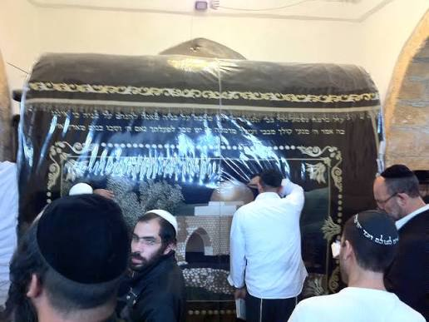
Kever Rachel – the Tomb of Our Matriarch Rachel/Rochel

He got so emotional that he actually passed out. A big commotion ensued. Finally, he was taken outside and revived. When he came to, there was a woman standing over him. It turned out it was his own mother! She was sobbing and weeping to see her son who she hadn’t seen for many years, laying on the ground at Kever Rachel!
When he was able to compose himself somewhat, he said to his mother, “You have to understand what happened here. I pushed my way firmly to be next to the tomb itself, put both hands on it, and cried out to HaShem. I said, ‘G-d Al-mighty, please show me a sign that there is anybody at all in the world who still cares about me!’
“Within seconds, I heard from the other side of the mechitsa a woman’s voice crying out and saying ‘Please! would You bring back my son.’ And then she pronounced my name and mother’s name! That was so overwhelming that I passed out”.
The reunion was the beginning of his rehabilitation and his return to a healthy lifestyle. Mother Rachel still cares!
Source: Freely adapted from a transcript of an aural Torah lesson by Rabbi Ari Shishler of Johannesburg, South Africa.

Reprinted from the Parshat Lech Lecha 5787 email of KabbalaOnline.org, a project of Ascent of Safed in Israel.

In the Merit of Reciting Birchas HaMazon Properly

Reb Shimon is an elderly Yid who lives in Yerushalayim. When he was young, before the Holocaust, he lived in Lublin. Rav Meir Shapiro, zt”l, once in a while would come to his Cheder to test the boys, and he would sometimes give out gifts or sweets to the children.
One time, Rav Meir Shapiro didn’t have anything to give them, and he said, “Instead of a gift, I will tell you a wonderful segulah, and if you will follow my advice, you will be always be successful and lead a peaceful life!” He then told them about the wonders that happen to people who say Birchas HaMazon properly, and he urged them to always use a Bentcher and not say it by heart. Rav Meir Shapiro concluded, “This is my present to you.” Reb Shimon took the lesson very seriously.
He decided right then that he would be careful with bentching for the rest of his life. It didn’t matter to him that his friends would bentch quickly and go out to play, while he stayed behind in order to bentch properly. It was challenging, but he didn’t want to abandon the wonderful gift that Rav Meir Shapiro gave him.
A few years later, the Nazis invaded Poland, and Reb Shimon found himself standing in line for a ‘selection’. People who were considered tall, were sent to the right, and were allowed to live, while those who were short were sent to the left for execution.
Reb Shimon davened that he should be saved from any “wrath and destruction” in the merit of Birchas HaMazon. When it was his turn, he stood as tall as he could to appear higher, and the Nazi signaled for him to go the right. He attributed his life being saved in the merit of bentching. Soon afterwards, Reb Shimon was standing in line again. This time, each person had to tell the Nazi in charge what his skills were, and Reb Shimon didn’t know what he could say, as he was only a teenager. As he waited in line he davened, “In the merit of Birchas HaMazon, which is a segulah for parnasah, Hashem, please support me.”
Suddenly, the person in line behind him tapped him on the shoulder and said, “Tell them that you are a cook and that you are my assistant. I will show you everything you need to know.” Reb Shimon said this and they were both sent to work in the kitchen, where he always had enough food to eat. Again, he attributed this Brachah to his being careful with how he recited Birchas HaMazon.
Reb Shimon continued to be extremely careful with bentching, and if he knew that he wouldn’t have enough time to bentch properly, then he wouldn’t eat bread. Once, on a freezing cold winter day, a Nazi saw Shimon working in the kitchen and he wasn’t pleased that he had such a ‘good’ position, surrounded with food.
The Nazi ordered Reb Shimon to go outside and showed him a stony area, outside the kitchen, and barked at him, “Dig a two-meter ditch here. You have two hours to finish, or else you will be buried in it,” and he handed him a spoon and said that was all he could use, and then he left. The task was absolutely impossible. The ground was covered with heavy stones, frozen solid, and all he had to use was a small spoon, all to be done in two hours.
Reb Shimon raised his eyes to Hashem and said, “I am careful to only say Birchas HaMazon with kavanah. Please save me again in this merit.” A few moments later a German jeep drove by, filled with Nazis, and they saw this young lad trying to dig a ditch with a spoon. To tease him, they threw potatoes, carrots, and other vegetables at him. Reb Shimon just collected them into a pile and continued his work.
Shortly afterwards a jeep with Russian workers drove up. When they saw all
the vegetables around Shimon, they stopped and asked for them. They were hungry,
because they were hardly fed by the Nazis. Reb Shimon told the Russians, “If you
help me dig a pit that measures exactly two meters deep here, I will give you all the
vegetables.” The Russians jumped at the offer and they all got right to work digging,
and as workers, they had exactly the right tools they needed. They all worked together and in just a few minutes they were able to finish the job. They took the vegetables and Reb Shimon went back into the kitchen, far earlier than his deadline.
The Nazi was happy to see him, knowing that he certainly failed in his mission, but his happiness ended when Reb Shimon told him the hole was finished. The Nazi ordered him back outside so he could inspect it, and when he saw that it was indeed complete, he said “I always knew that your G-d takes care of you. I just didn’t realize to what extent,” and he never bothered Reb Shimon again. Reb Shimon was saved once again, and he attributed it to the merit of bentching.
When he came to Eretz Yisroel after the war was over, he continued to enjoy many brachos of abundance, and he was able to resume saying Birchas HaMazon as he had his entire life!

Reprinted from the Parshas Lech Lecha 5787 email of Rabbi Yehuda Winzelberg’s Torah U’Tefilah.
The Power of Tzekah
Given to the Poor

Rebbe Mordechai of Zvhil, zt”l, was known for the power of his brachos, even when he was still young and did not yet have a very large following as a Rebbe. One time, someone who was suffering an illness came to visit him and asked for a brachah for a refuah sheleimah, and gave him a large amount of money.
Rebbe Mordechai gave him a Brachah, and shortly afterwards, the man was healed. Thirty years later, that man’s illness returned to him. By that time, Rebbe Mordechai was known as the Zvhiller Rebbe.
The man once again took a lot of money and went to get a brachah from the Rebbe, and requested that the Rebbe please daven on his behalf. The Rebbe replied, “I have a suggestion for you. I know someone who is struggling because he is very poor. Why don’t you take the money you are offering me and give it to him instead? He will also daven for you, and with Hashem’s help, you will have a complete recovery.”
The man said, “Rebbe, thirty years ago, I was sick with the same illness, and my Refuah came when I gave money to you and you davened for me, and now I would like to do the same thing and give you money again.”
The Zvhiler Rebbe responded, “Thirty years ago, I was a very poor man myself. When you gave me the money back then and had a complete recovery, it was in the merit of giving Tzedakah that you were healed. But now, Baruch Hashem, I don’t need the money. Therefore, I advise you to give your money to the poor. The merit of giving Tzedakah will surely help you recover once again, and I will surely Daven for you again!”
The man listened as he was advised by the Rebbe, and shortly after, he was completely healed!

Reprinted from the Parshas Lech Lecha 5787 email of Rabbi Yehuda Winzelberg’s Torah U’Tefilah.

